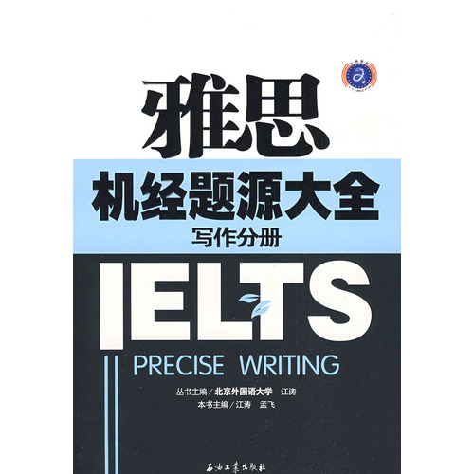
Introduction
The reproduce Zhenti: nearly two years IELTS exam Zhenti in pooling machine by candidates memories, combined with foreign authoritative information to reproduce the original appearance of the previous IELTS Writing Zhenti in. Is a veritable "IELTS Writing Exam.
Detailed parsing: for every IELTS Writing Zhenti in clarifying ideas, coaching format, while providing the Native the Speaker surgeon score of sentence patterns and colorful Appreciation.
Categories: sorting the Class A pie chart, Class G Letter Writing and Argumentative Writing. The argumentative part, summarized by five kinds of writing style classification 9 categories of education, sports, media, public service and other topics.
Examination necessary: ​​"The examination time, place, set the" restore duck Friends of Zhenti title source analysis "recite sentences of the" high score, the more colorful appreciate topics essential vocabulary practical plate , meet the candidates need to maximize.
Directory
The first chapter of the IELTS writing class of the Task 1 (chart composition) Zhenti, question the source of a curve Line chan
Topic One of England and into Wales three the number of criminal acts
Topic Two "UK private car ownership changes, tables Table
Topic One, the female share of employment in government agencies and senior management
Two topic "gender and academic achievement," the relationship
Topic Three "advertising" cost and utilization of different forms of advertising
Topic four countries of the Four "demographic changes" to the three pie charts Pie chan
Topic One "main reason for a UK university."
Topic Two 2OO3 South Korea to play "video games" the proportion of people
The topic the Three students on the library's "Technical Support" and "open time" Satisfaction, Histogram Bar Graph
Topic One to participate in sports for children sex "differences

